PRESS RELEASE
COMMUNICATIONS AND MEDIA TEAM OF THE 43RD ASEAN SUMMIT 2023
No.105/SP/TKM-ASEAN2023/ENG/9/2023

2023 ASEAN Summit Gala Dinner Cuisine and Entertainment Presented to Perfection
Jakarta, 6 September 2023 – Gala Dinner of the 43rd ASEAN Summit took place at Plataran City Forest of Senayan in Jakarta, has clearly demonstrated Indonesia as a country full of hospitality and treat its guests with the highest honor.
Starting from the decoration at the entrance, banquet menu, to entertainment and souvenirs, all showcased the best side of Indonesia. Pride in the abundant natural richness the mother nature has given, is shown in the various forms of presentation for the guests.
In addition to the special delicious Indonesian gourmet food, state and honorary guests were entertained with singing and cultural performances by talented Indonesian young artists. The performances were divided into four major themes. The Gala Dinner was opened with a musical performance featuring the Sasando, a stringed musical instrument from Rote Island of East Nusa Tenggara province, that accompanied a song titled “Mahadaya Cinta” sung by singer Dira Sugandi.
The first theme is “The Sound of Indonesia”, which depicts enthusiasm and productivity. This theme was perfectly illustrated through a percussion performance. Four Indonesia’s traditional dances, namely the Alu Dance, Lesung Dance, Dol Dance and Kipas Dance completed the first round of performances. Everything is performed in rancak (dynamic) dance movements meant to convey the celebration and festivity of the harvest season.
Those dances are usually performed to welcome guests, so they suit the Gala Dinner moment. The performance of these four dances reflects the joy of hosting all guests of state. Apart from that, it is expected that everyone could be inspired by rancak (dynamic stomp) movements by the dancers and musicians’ cooperative effort to present beauty. ASEAN must work together as one to realize its goal of equal and prosperous Southeast Asia.
The second theme was The Soul of ASEAN. This theme highlighted a celebration of diversity and the rich cultural heritage of ASEAN member states. 100 dancers performed various traditional dances continuously. The harmony exhibited the ASEAN spirit of realizing "One Vision, One Identity, and One Community."
The third theme “the Wave of Tomorrow” described the shared vision of each ASEAN member country to utilize science, technology and innovation to ensure the region's collective vision of sustainable development. Guests were entertained with inspirational songs featuring sophisticated technology that provides a new entertainment experience to demonstrate the wave of the future.

The theme The Epicentrum of Growth raised Indonesia's chairmanship in ASEAN this year. It Presented ASEAN's vision as the epicenter of growth, in line with the establishment of the ASEAN Community which seeks to elevate the growth potential of each country. This theme featured a selection of upbeat and lively songs to describe ASEAN's strength.
All performances were presented on an outdoor stage with the city's skyscrapers turn into a big backdrop for the dazzling light and multimedia displays. Magnificent and classy!
***

For more information, please contact:
Director for Information and Media Services of the Ministry of Foreign Affairs – Hartyo Harkomoyo (0811831899)
Get more information at http://asean2023.id, https://infopublik.id/kategori/asean-2023, and https://indonesia.go.id/kategori/ragam-asean-2023

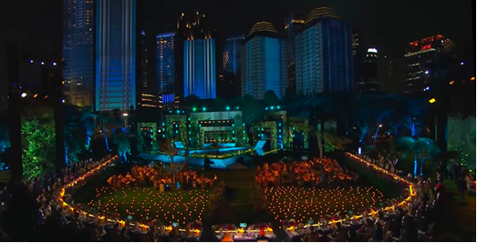

The ambience during the 43rd ASEAN Summit Gala Dinner at the Plataran City Forest, Senayan, Jakarta, Wednesday, 6 September 2023.

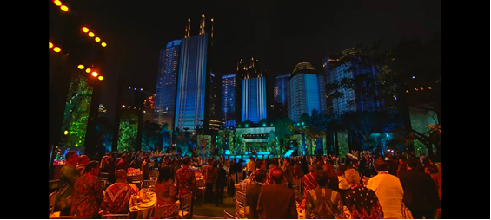

The ambience during the 43rd ASEAN Summit Gala Dinner at the Plataran City Forest, Senayan, Jakarta, Wednesday, 6 September 2023.

